**DAILY ONLINE ACTIVITIES SUMMARY**

|  |  |  |  |  |  |  |  |
| --- | --- | --- | --- | --- | --- | --- | --- |
| **Date:** | **18/06/20** | | | | **Name:** | **Bhuvana S** | |
| **Sem & Sec** | **8th sem A sec** | | | | **USN:** | **4AL16CS022** | |
| **Online Test Summary** | | | | | | | |
| **Subject** | | **SMS** | | | | | |
| **Max. Marks** | | **60** | | **Score** | | **Confidential** | |
| **Certification Course Summary** | | | | | | | |
| **Course** | **Introduction to Digital Marketing** | | | | | | |
| **Certificate Provider** | | | **Great Learning Academy** | **Duration** | | | **2.5hrs** |
| **Coding Challenges** | | | | | | | |
| **Problem Statement: Write a C program to generate first N magic numbers** | | | | | | | |
| **Status: Completed** | | | | | | | |
| **Uploaded the report in Github** | | | | **Yes** | | | |
| **If yes Repository name** | | | | **bhuvanashivakumar** | | | |
| **Uploaded the report in slack** | | | | **Yes** | | | |

Certification Course Details:

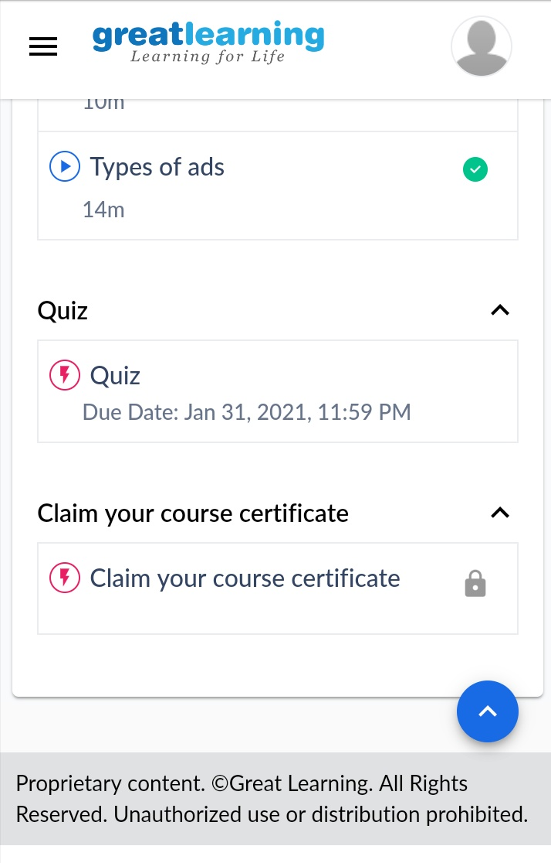

Coding Challenges Details:

PROGRAM 1 .

//Write a C Program to generate first N Magic Numbers

#include <stdio.h>

int nthMagicNo(int n)

{

int pow = 1, answer = 0;

while (n)

{

pow = pow*5;

if (n & 1)

answer += pow;

n >>= 1; // or n = n/2

}

return answer;

}

int main()

{

int n = 5;

printf("nth magic number is %d\n",nthMagicNo(n));

return 0;

}